**HEATH END VILLAGE HALL**

**RULES AND CONDITIONS OF HIRE**

We reserve the right: і) to refuse any booking

іі) to cancel any booking made which the Hall Management   
 Committee deem unsuitable to be held in the Hall.

**NOTE : Bookings for parties for 16 to 21year olds will NOT be accepted.**

1. **The Hirer,** being a person over 25, must remain on the premises throughout the hire and is responsible for the supervision of the premises, the care of the fabric and the contents.
2. If the Hirer wishes to cancel the booking within 4 weeks of the event and the Committee is unable to secure a replacement booking, the deposit will not be refunded.
3. **A Damages deposit of £150.00** will be paid by the Hirer to the Committee, who, **within 28 days of termination of the period of hire**, will repay such amount to the Hirer, less cost of rectifying any damage, removal of rubbish or extra cleaning required at £20 an hour.
4. A current Disclosure and Barring Service (DBS) check is required by those dealing with children and vulnerable people.
5. The Hirer is responsible for reading and complying with The Rules and Conditions of Hire, which are displayed on the notice board in the Hall foyer and sent out with the Booking Form.
6. The Booking Secretary will arrange collection of keys and a tour of the premises prior to the date of the hiring. Please ensure keys are returned into the key drop box immediately after the hiring.
7. **GENERAL CONDITIONS**

**a. HOURS OF OPENING**

The premises are licensed for public entertainment only between the hours of 09.00 and 23.00 Monday to Sunday. The Hall must be vacated by 24.00 hrs. The Hall is not licensed for use on Christmas Day. Should a Hirer wish to run an event outside these hours they can apply for a Temporary Event Notice (see (J) below).

It is the responsibility of the Hirer to make sure that no music, dancing or other licensable activity takes place outside the permitted hours.

**b. CAPACITY**

The number of people on the premises shall not exceed 230.

**c. HEATING**

No additional heating appliances shall be used on the premises, when open to the public.

**d. OUTBREAKS OF FIRE**

The Fire Brigade shall be called to any outbreak of fire however slight, or upon activation of the fire alarm. The Hall shall be evacuated and all occupants directed to the assembly point at the opposite side

of the Green, by the Scout Hut, Ash Lane, as illustrated in the Fire Action Notices, posted on the notice board, in the Hall foyer. The Bookings Secretary or another Committee member must be informed of all details, immediately.

Only once that the fire is extinguished and the building deemed safe to enter can the fire alarm be silenced.

Full instructions for silencing the alarm are on the fire control panel in the foyer

Please advise the Hall committee of the situation regardless of a fire or false alarm

**e. ELECTRICAL EQUIPMENT**

Any electrical equipment (e.g. disco/music playing equipment etc) must have a

current Portable Appliance Test (PAT) certificate to comply with the BS 7671 (Institution of Engineering and Technology 18th edition Wiring Regulations amended 2018).

If PAT testing is required before use, the Hall Management Committee may be able to provide the name of an electrician. Please speak to the Bookings Secretary, in the first instance.

**f. BOUNCY CASTLES**

Bouncy Castles are allowed as long as suitable for indoor use.  They must be no more than 3.1 metres high, 3.2 metres deep at the highest point (the front entrance area may extend further if required) and 4 metres wide and must be positioned at the far end of the Hall between the ballet bar and the hanging spotlights, ensuring that they do not touch either and that there is access to the fire doors and back entrance. Alternatively, they may be positioned on the green outside. See Appendix 1 for details of positioning.

**g. DISCOS**

There shall be no special effects i.e. Stroboscopic lighting, smoke, lasers, real flame, pyrotechnics, firearms, fireworks or foam etc. allowed.

**h. BALL GAMES**

Ball games are only allowed **outside** the Hall on the Green.

**i. ACCIDENTS**

All accidents occurring in any area of the premises or the surrounds must be recorded on an Accident Report form, copies of which are in in the Kitchen, in the First Aid Equipment Box. Completed forms must be returned to the Bookings Secretary with the keys. All major accidents requiring an ambulance or paramedic and admission to hospital must be reported to the Bookings Secretary as soon as possible. The Hall Management Committee must notify Basingstoke and Deane Borough Council Environmental Health Department of the incident.

**j. ALCOHOL**

The Hall is not licensed for the sale of alcohol**.** If the Hirer wishes to sell alcohol, a Temporary Event Notice (T.E.N.) must be obtained from Basingstoke and Deane Borough Council, (B&DBC) at least 10 working days before the event. Further information can be obtained from B&DBC. Tel.01256 844844, E-mail : [licensing@basingstoke.gov.uk](mailto:licensing@basingstoke.gov.uk). Internet web site : [www.basingstoke.gov.uk](http://www.basingstoke.gov.uk/)

If you are not charging anyone for your event, you may supply alcohol, or ask guests to bring their own.

If tickets are being sold for the event, the inclusion of free alcohol in the ticket price requires a T.E.N., although guests may bring their own.

**k. FILMS**

No Licence or Temporary Event Notice is required for a performance of amplified live music or the playing of recorded music between 09:00 and 23:00 at Heath End Village Hall provided the audience does not exceed 200 and the Hirer gets consent for the performance from the Bookings Secretary.  Further, no licence or Temporary Event Notice is required for a not for profit film exhibition held at a Heath End Village Hall between 09:00 and 23:00 provided the audience does not exceed 200, the Hirer gets consent to the screening from the Bookings Secretary; and ensures that the screening abides by age classification.

**l. TELEVISION**

No live streaming of television programmes, or use of catch-up TV such as i-Player is allowed. The Hall does not have a TV licence.

1. **GENERAL**

**a. No animals, except Assistance Dogs, are permitted on the premises.**

The car park is provided for Hirer’s use. All cars are parked at owner’s risk.

Please do NOT use sellotape or similar, to fix decorations to the walls of the Hall. If blue tac is used, it must be removed at the conclusion of the hire period. A wooden batten has been fixed in the main Hall for the purpose of fixing decorations.

**b. DOORS**

The front security doors must not be locked during the entire period of use.

The glazed lobby doors must NOT be propped open or obstructed in any way during the entire period of use.

The fire exit doors must NOT be obstructed in any way during the entire period of use.

The fire exit doors to the village green MUST BE CLOSED when music of any sort is being performed in the Hall.

1. **NOISE**

Please consider the neighbours of the Hall and keep noise to a minimum when entering or leaving the premises.

There is a noise delimiter fitted in the Hall which will activate if the noise exceeds the permitted limit. If you are having a disco this will most likely trigger, so please let us know in advance so that we can agree what to do.

1. **PRIVACY NOTICE**

Heath End Village Hall uses personal data for the purposes of managing the Hall bookings and finances, running and marketing events at the Hall and its fundraising activities. Data may be retained for up to 7 years for accounts purposes and for longer where required by the Hall’s insurers. If you would like to find out more about how we use your personal data or want to see a copy of information about you that we hold please contact the Secretary.

1. **COMPLETION OF HIRE**

**The Hirer must leave the Hall in a clean and tidy condition, at the end of the period of hire: floors to be swept, work surfaces and table tops to be wiped. Please replace chairs and tables in the store, and check the toilets for cleanliness**.

**All rubbish from the Hall and the Green including bottles to be taken home.**

**On leaving, please ensure the heating is off, the lights are out and the doors are locked.**

**Notify the Booking Secretary of any damage or incidents.**

**Deposit the Hall keys in the drop box.**

**THANK YOU**

**Appendix 1.**

**Diagram of Bouncy Castle Positioning**

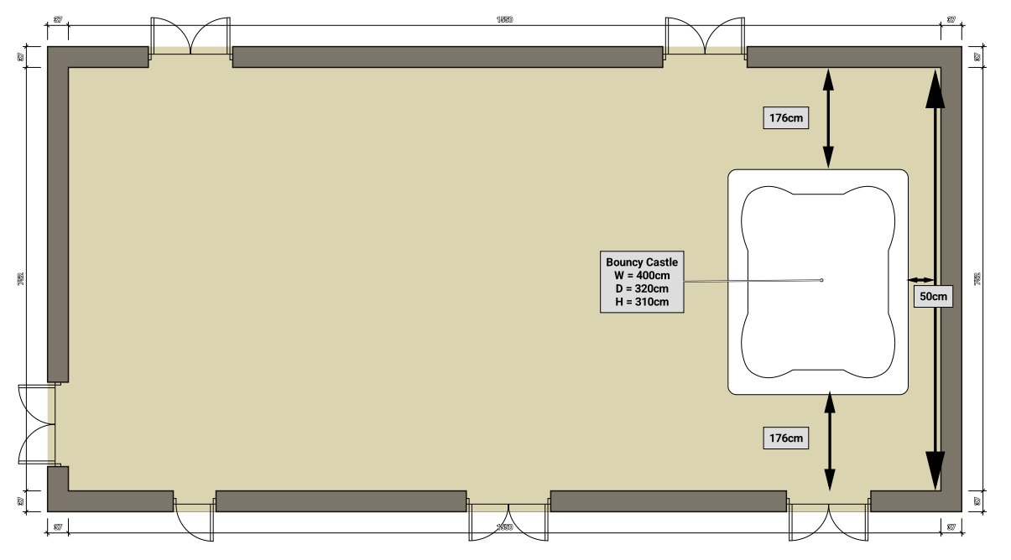

**A Couple of Bouncy Castle Providers**

Bouncy Castle Kingdom: [https://www.bouncykingdom.co.uk/booking.aspx?id=5#bookingForm](https://www.bouncykingdom.co.uk/booking.aspx?id=5" \l "bookingForm)

Bounce 4 Fun – 07525 656160 - <http://www.bounce-4-fun.co.uk/forhire-bouncy-castles.html>